Abhishek Kumar
DATA Structures VIVA
Dated- 15th November 2022

CODE
#include<stdio.h>
#include<stdlib.h>
#include<string.h>
void insertele();
void searchele();
void deleteele();
void showele();
struct node{
char name[50];
int age;
char place[50];
struct node* link;
};
struct node* start = NULL;
int main(){
int choice;
while(1){
printf("\nMenu: ");
printf("\n1. Insert Entries ");
printf("\n2. Search And Replace Entries ");
printf("\n3. Delete Entries. ");
printf("\n4. Show Entries. ");
printf("\n5. Exit.");
printf("\nEnter Your Choice: ");
scanf("%d",&choice);
switch(choice){
case 1: insertele();
break;
case 2: searchele();
break;
case 3: deleteele();
break;
case 4: showele();
break;
case 5: exit(0);
default: printf("\nInvalid choice!");
}
}
return 0;
}
void insertele(){
struct node* temp,*q;
temp=(struct node*)malloc(sizeof(struct node));
printf("\n___________Insertion Function:_____________ ");
printf("\nEnter Details: ");
printf("\nName: ");
scanf("%s",&temp->name);
printf("\nAge: ");
scanf("%d",&temp->age);
printf("\nPlace: ");
scanf("%s",&temp->place);
temp->link=NULL;
if(start==NULL){
start=temp;
q=temp;
}
else{
temp->link = start;
start = temp;
}
printf("\nElement Added!");
return;
}
void deleteele(){
printf("\n_____________Deletion Function:_______________ ");
struct node* temp,*new;
temp=start;
while(temp!=NULL){
if(temp->age>=90)
{
struct node* temp;
if (start == NULL)
printf("\nList is empty\n");
else {
new = start;
start = start->link;
free(new);
}
}
temp=temp->link;
}
showele();
return;
}
void searchele(){
printf("\n________________Searching Function:_______________ ");
struct node* temp;
temp=start;
while(temp!=NULL){
if((strcmp(temp->place,"Delhi")==0))
{
strcpy(temp->place,"New Delhi");
}
else
return;
temp=temp->link;
}
return;
}
void showele(){
printf("\n_____________Display Function:_____________");
struct node* temp;
temp=start;
int i=1;
while(temp!=NULL){
printf("\n__________Details of User %d are_______",i);
printf("\nName: ");
printf("%s",temp->name);
printf("\nAge: ");
printf("%d",temp->age);
printf("\nPlace: ");
printf("%s",temp->place);
temp=temp->link;
i++;
}
return;
}

Output

Insertion:

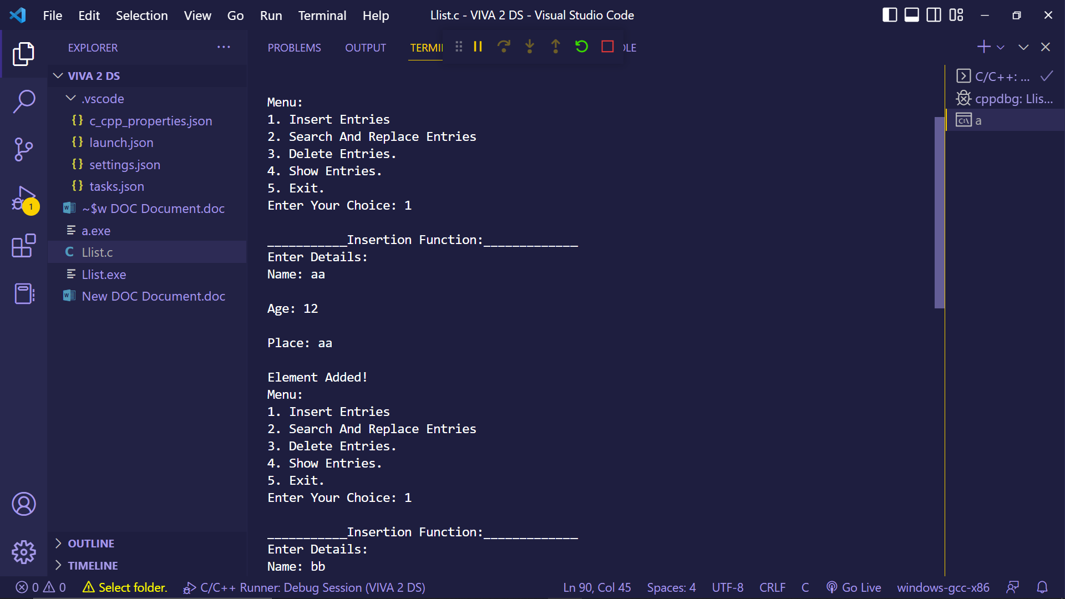

Show:

